**Note:**

**“In dit document plaats ik wekelijks enkele screenshots van wat ik gedaan heb”**

**Initiële setup WDIO in VS code omgeving**

**

**Test laten falen om te verifiëren of de test werkt zoals verwacht**

**Labo 1**

**Upload tests**

**WDIO debug modus**

**Page class voor home page**

**Page Component voor navigatie**

**Labo 2 Page Object Model**

**Test Hooks**

**Global Hooks**

**Random test data a.d.h.v. faker.js library**

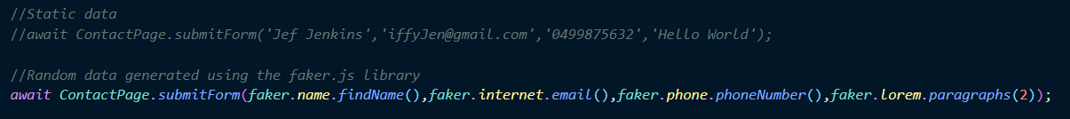

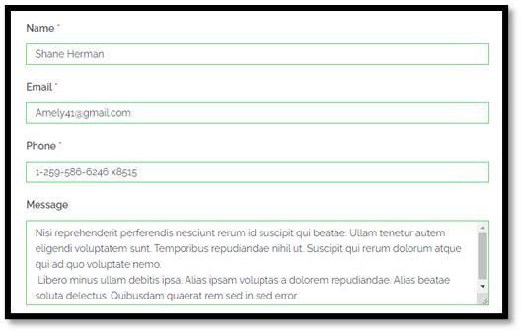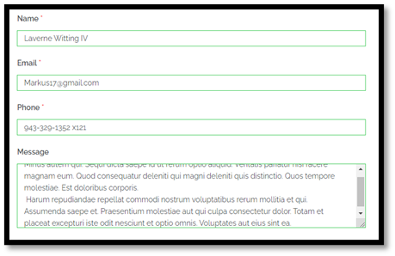**Verschillende input data bij elke test uitvoering.**

**Test suite definiëren en uitvoeren**

**Uitvoeren individuele test met CLI**



**Configuratie: Test files die genegeerd moeten worden bij uitvoering.**

**Exclude tests via CLI**



**Cross-browser testing op Chrome & Firefox**

**Genereer HTML report met Allure**

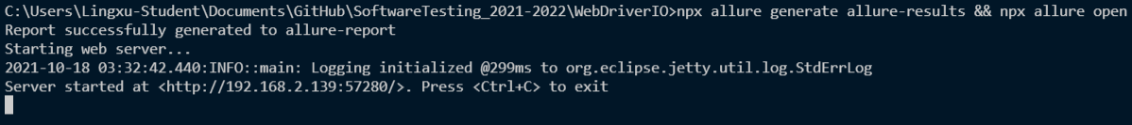

**Test rapport bij test failure & screenshot capture.**

**Browserstack online reporter**

**Jenkins job & configuratie**

**Testen uitvoeren in Jenkins**

**Week 9, 17/11/2021**

**Aangepaste setup WebdriverIO voor CucumberJS**

**Eerste feature specificatie**

**Bijhorende step-definitions:**

**Feature testen**

**CucumberJS uitbreiding**

**Uitgebreide feature met data table:  
**

**Bijhorende step definitions:**

**Testen geslaagd na meerdere uitvoeringen**

***Gif aanklikken om af te spelen***

